- INTRODUCTION
Through our project, we propose a system which takes as input the symptoms of the patient to predict the disease, which is followed by recommending the appropriate medicine. To simplify the task of the user, instead of having to answer multiple questions which normally constitutes a consultation, the user will simply have to enter the symptoms they are exhibiting. The medical data regarding the symptoms will be stored as a dataset. The task of the system is to respond to the query given by the user by employing a suitable machine learning model on the dataset.
The symptoms of the patients are taken by the doctors for the continuous evaluation of vitals like heart rate, blood pressure, sugar level etc for the analysis. A doctor can search in the system. The system will respond according to the High Technology Letters corresponding dataset. This system is mainly designed to help doctors integrate prediction modules and recommendation modules so that it can recommend medicines based on the respective disease, and thereby constitute a thorough system
- This practice leads to unwanted Biases, errors and excessive medical costs which affects the quality of service provided to patients
- Thus we proposed that integration of clinical decision support with computer-based patient records could reduce medical errors, enhance patient safety, decrease unwanted practice variation, and improve patient outcome
- This suggestion is promising as data modeling and analysis tools, have the potential to generate a knowledge-rich environment which can help to significantly improve the quality of clinical decisions
- The main objective of this research is to develop prototype Intelligent disease Prediction System (IHDPS) using three data Mining modeling techies, namely. Decision Trees Naive Bayes and random forest
- So its providing effective treatments, it also helps to reduce treatment costs. To enhance visualization.

  - OBJECTIVES
It is estimated that more than 70% of people in India are inclined to general body maladies like viral, flu, cough, cold etc, in every 2 months. Since numerous individuals don't understand that the general body illnesses could be side effects to something increasingly hurtful, 25% of the populace surrenders to death because of ignoring the early general body symptoms
The currently available systems are the systems that are either devoted to a particular sickness or are in the research phase for algorithms when it comes to generalized disease.
1.2 SCOPE
Among various life-threatening diseases, disease has garnered a great deal of attention in medical research. The diagnosis of disease is a challenging task, which can offer automated prediction about the condition of patient so that further treatment can be made effective. The diagnosis of disease is usually based on signs, symptoms and physical examination of the patient. There are sevenl factors that increase the risk of disease, such as smoking habit, body cholesterol level, family history of disease, obesity, high blood pressure, and lack of physical exercise.

  - PURPOSE
- The main objective of this research is to develop prototype Intelligent disease Prediction System (IHDPS) using three data Mining modeling techies, namely. Decision Trees Naive Bayes and random forest.
- So its providing effective treatments, it also helps to reduce treatment costs to enhance visualization.
- This practice leads to unwanted Biases, errors and excessive medical costs which affects the quality of service provided to patients.
- Thus we proposed that integration of clinical decision support with computer-based patient records could reduce medical errors, enhance patient safety, decrease unwanted practice variation, and improve patient outcome.
- This suggestion is promising as data modeling and analysis tools, have the potential to generate a knowledge-rich environment which can help to significantly improve the quality of clinical decisions.

- PROPOSED SYSYTEM
2.1 Feasibility Study
- The project is technically feasible as it can be built using the existing available
- technologies. It is a web based applications that uses Django Framework. The technology
- required by Disease Predictor is available and hence it is technically feasible.
2.2 Economic feasibility
- The project is economically feasible as the cost of the project is involved only in the
- hosting of the project. As the data samples increases, which consume more time and
- processing power. In that case better processor might be needed.
2.3 Operational feasibility
- The project is operationally feasible as the user having basic knowledge about computer
- and Internet. Disease Predictor is based on client-server architecture where client is users
- and server is the machine where datasets are stored.

3.SURVEY OF TECHNOLOGIES
1. RDBMS And MySQL database
A database is a separate application that stores a collection of data. Each database has one or more tables for creating, accessing, managing, searching and replicating the data it holds.
Other kinds of data stores can also be used, such as files on the file system or large hash tables in memory but data fetching and writing would not be so fast and easy with those type of systems.
Nowadays, we use relational database management systems (RDBMS) to store and manage huge volume of data. This is called relational database because all the data is stored into different tables and relations are established using primary keys or other keys known as Foreign Keys.
2.About MySQL.
- MySQL is a fast, easy-to-use RDBMS being used for many small and big businesses.. MySQL is becoming so popular because of many good reasons −
- MySQL is released under an open-source license. So you have nothing to pay to use it.
- MySQL uses a standard form of the well-known SQL data language.
- MySQL works on many operating systems and with many languages including
- Python,PHP, PERL, C, C++, JAVA, etc.

4.SOFTWARE AND HARWARE REQUIREMENTS
Software Resource:
Name of Component | Specification
Operating System | Windows 98 and above
Language | Python 3.7
Database | MySQL
Browser | Chrome, Mozilla etc
Web Server | Django
Scripting Language | PythonScript

Hardware Resource:
Name of Component | Specification
Processor | Pentinum II and above
Ram | 128MB
Hard Disk | 20GB
Monitor | 15 inch

5.SNAPSHOT OF INTERFACES

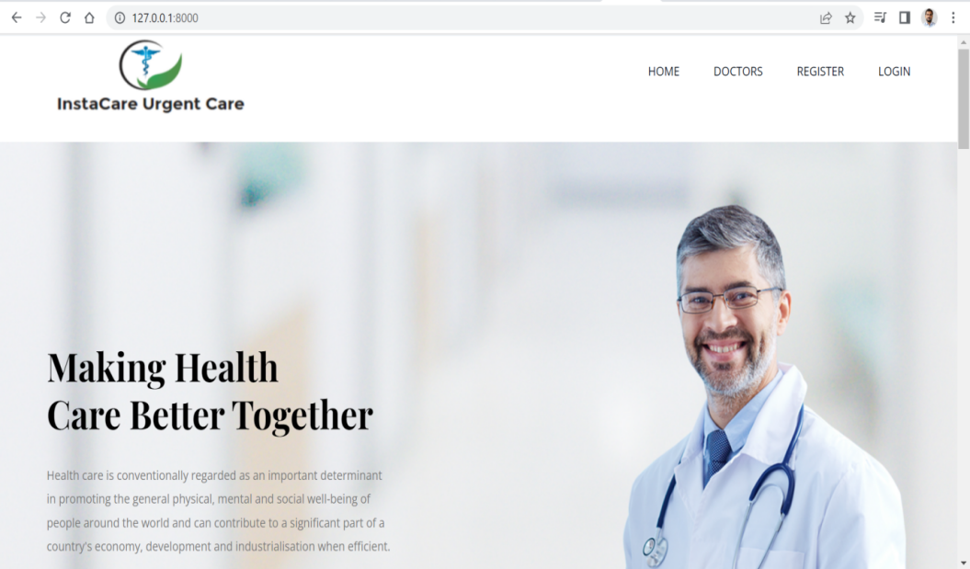
1.Home page:

2.Home page(continue):
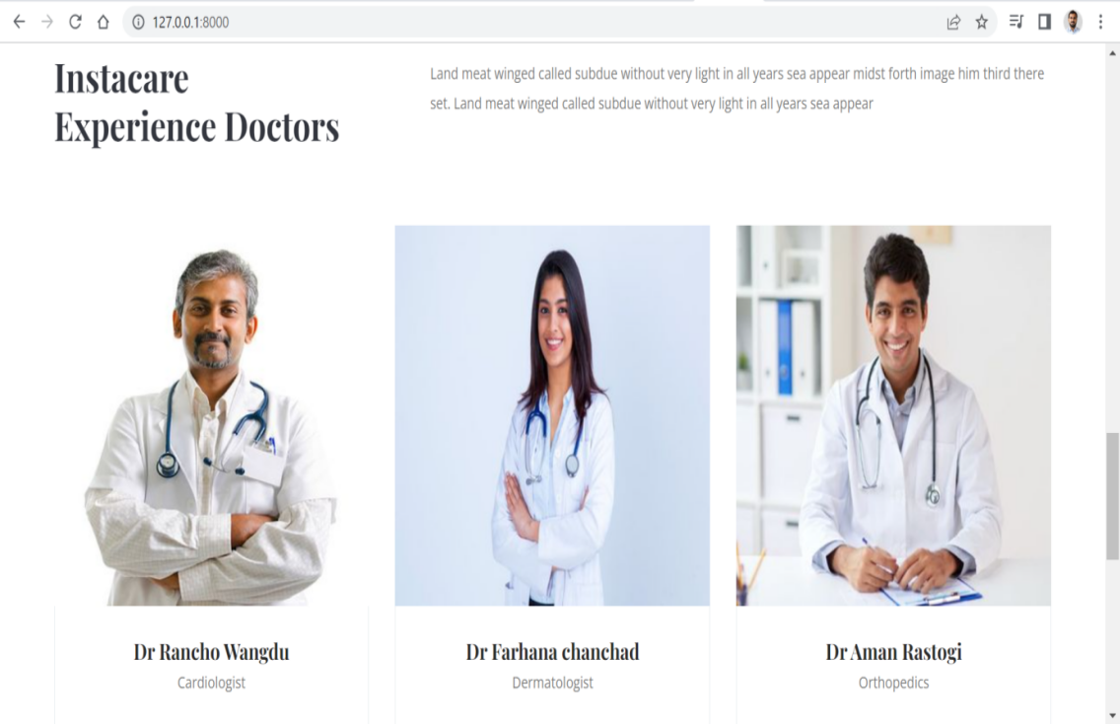

3 Home page(continue)
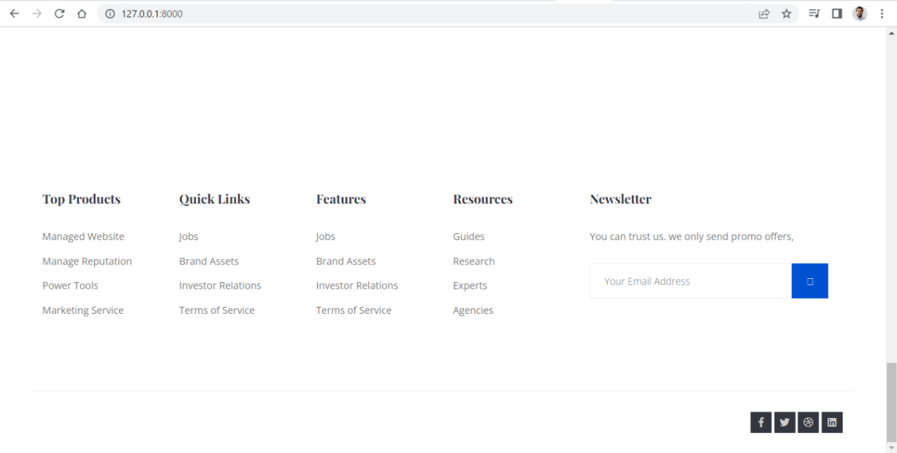

4. Patient Registration
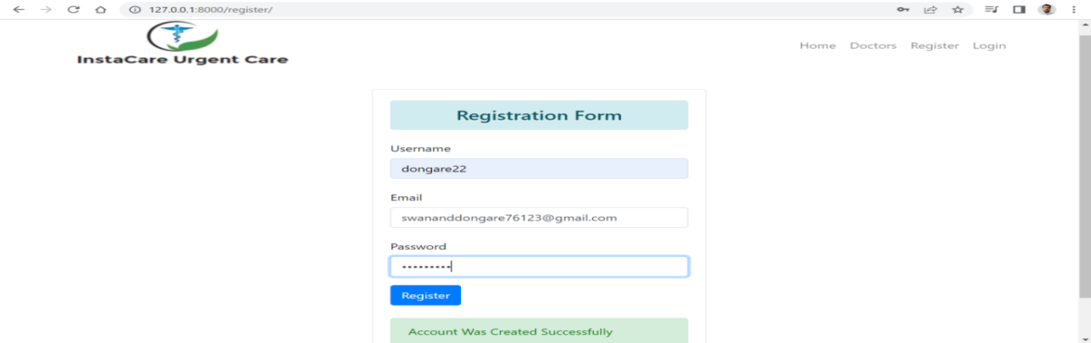

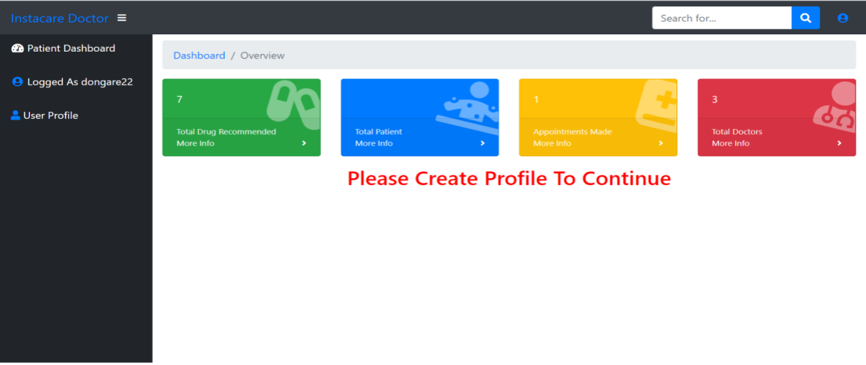
5.After login successful
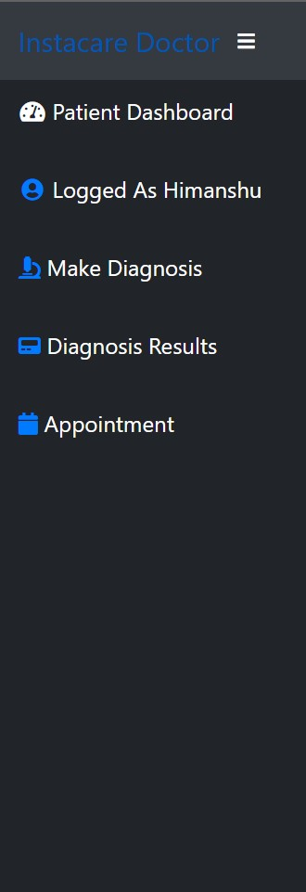

6.Create your profile.
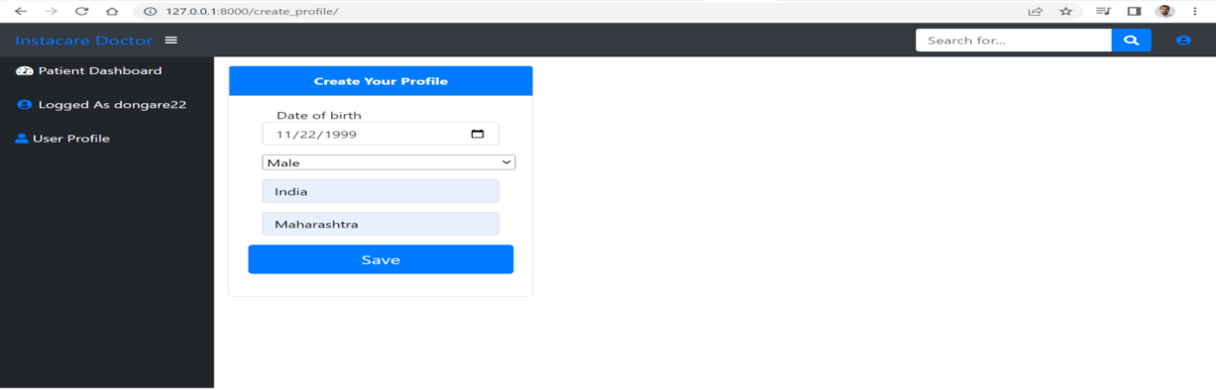

7.Profile created successfully

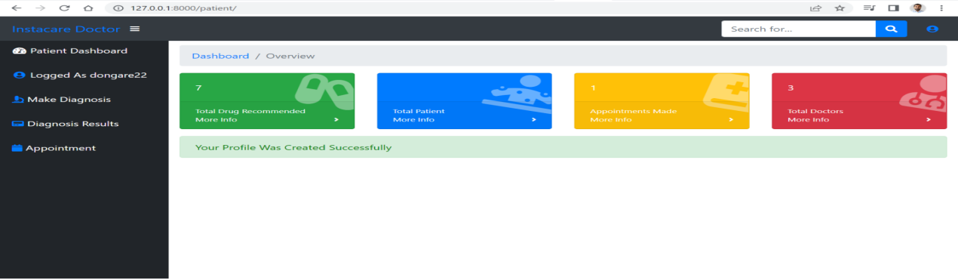

8.Make diagnosis

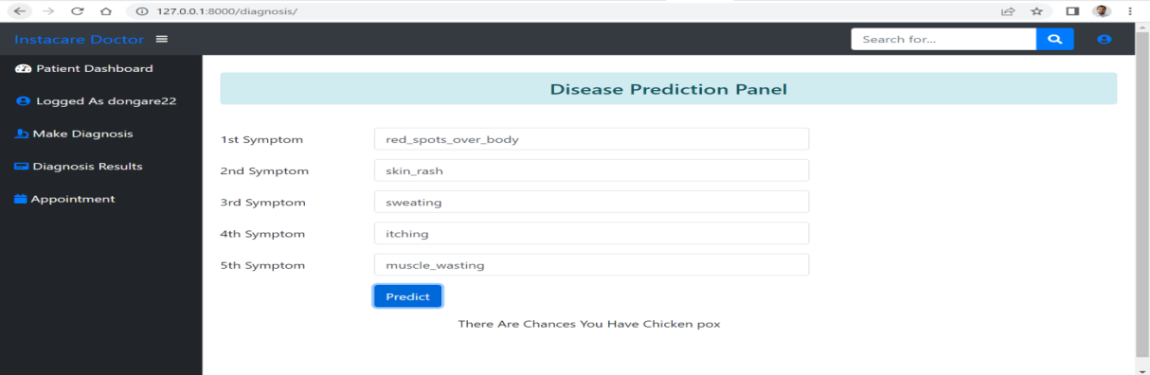

9.Diagnosis result
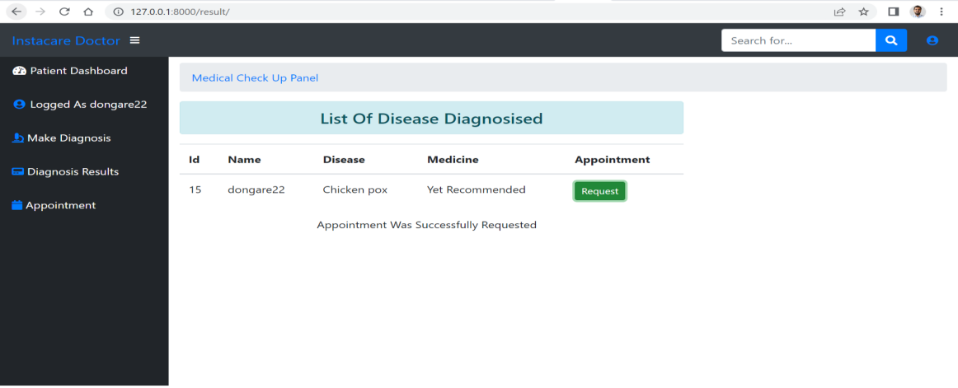

10.Doctor Login
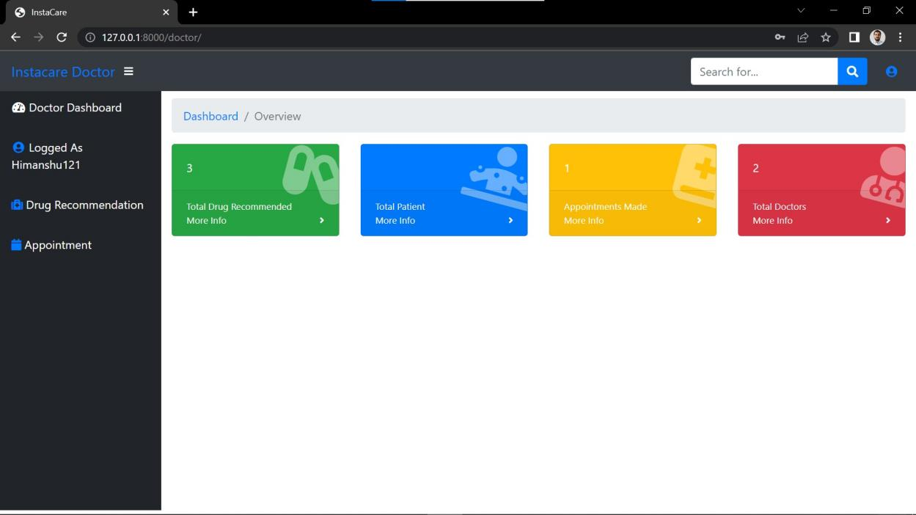

11. Appointment approved
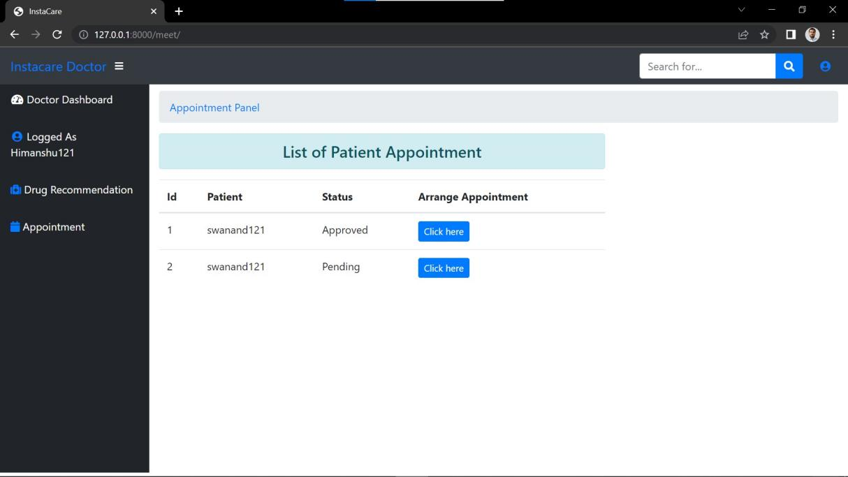

6.SYSTEM DESIGN
1. Data Flow Diagram
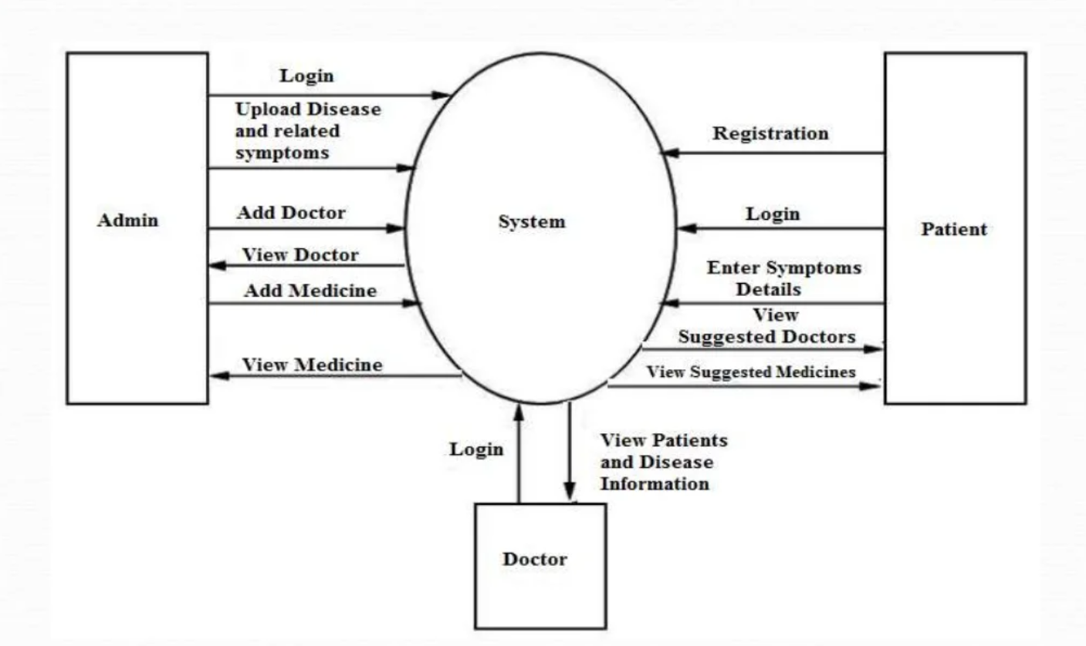

2.Entity Relationship Diagram
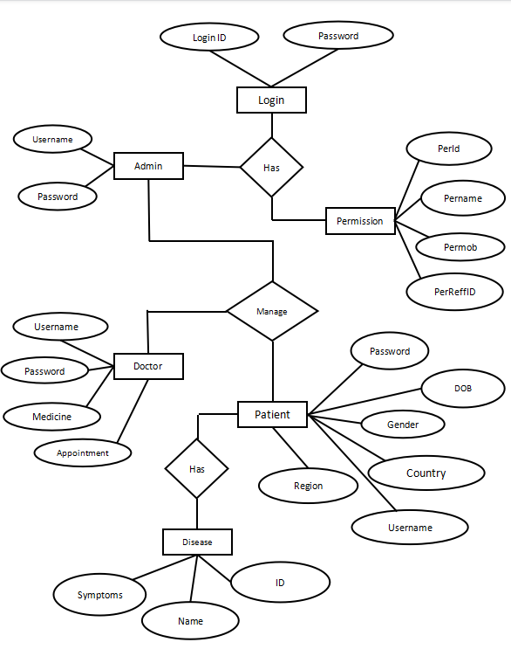

Use Case Diagram system

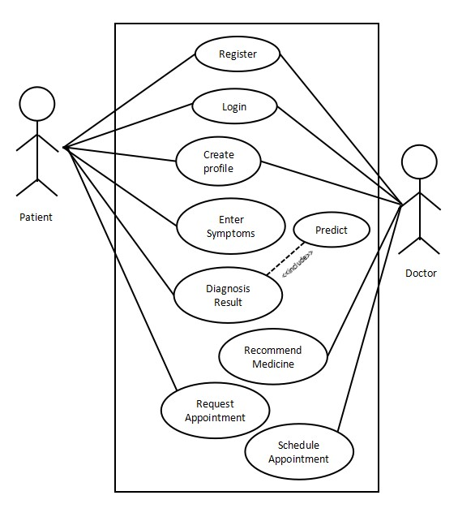

Use Case Diagram for Disease diagnosis
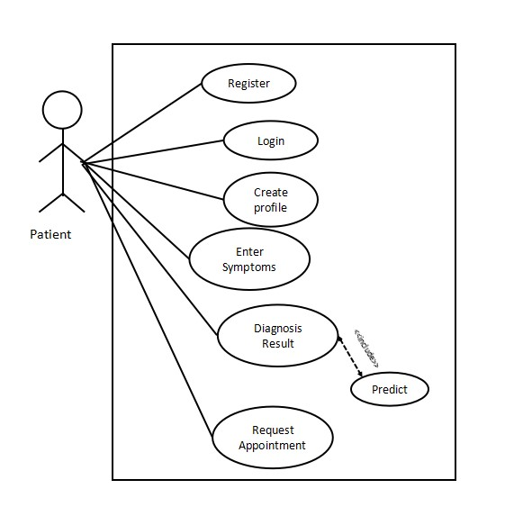

4.Activity Diagram
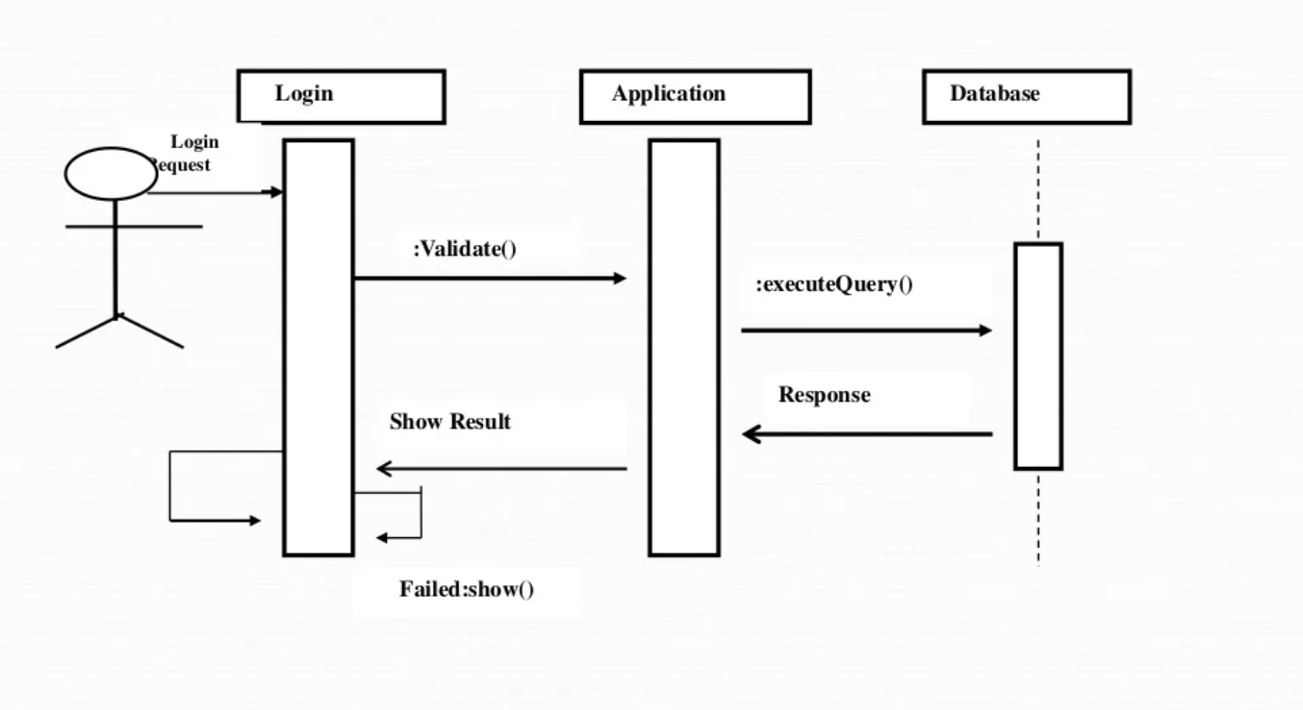

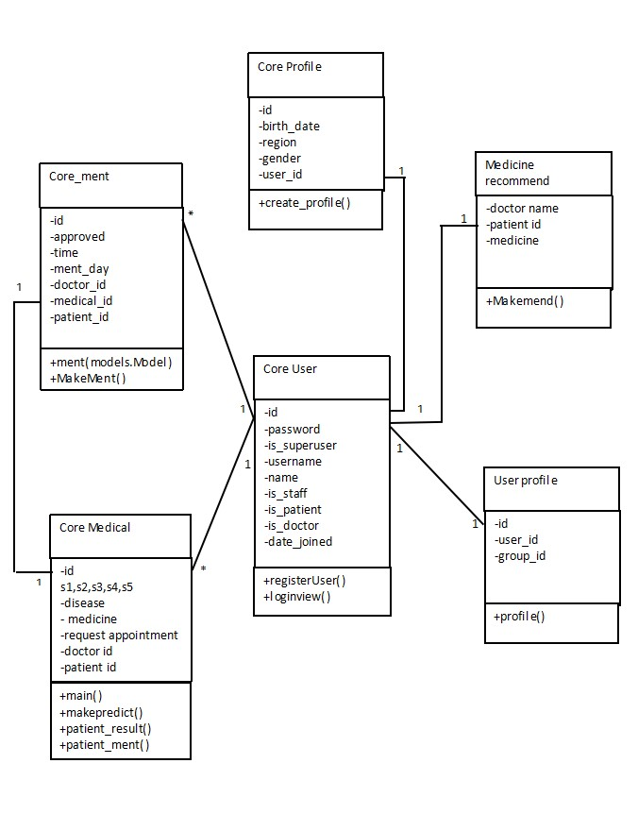
5.Class Diagram

6.Sequence Diagram
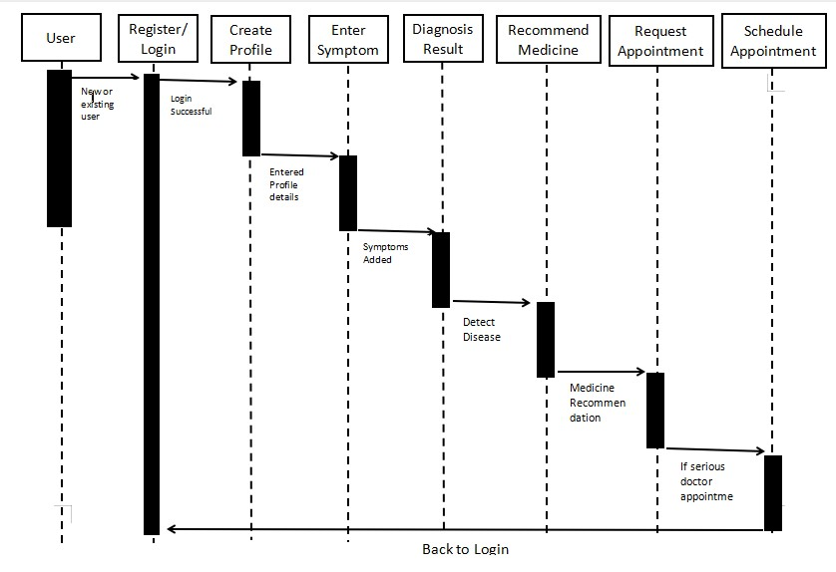

7.CODING
Models.py
from django.db import models
from django.contrib.auth.models import AbstractUser
from django.contrib.auth.models import User
from django.contrib.auth import get_user_model

class User(AbstractUser):
is_patient = models.BooleanField(default=False)
is_doctor = models.BooleanField(default=False)
phonenumber = models.CharField(max_length=200,null=True)
class Medical(models.Model):
s1 = models.CharField(max_length=200)
s2 = models.CharField(max_length=200)
s3 = models.CharField(max_length=200)
s4 = models.CharField(max_length=200)
s5 = models.CharField(max_length=200)
disease = models.CharField(max_length=200)
medicine = models.CharField(max_length=200)
patient = models.ForeignKey(User, related_name="patient", on_delete= models.CASCADE)
doctor = models.ForeignKey(User, related_name="doctor", on_delete= models.CASCADE, null=True)
created_on = models.DateTimeField(auto_now_add=True)
def __str__(self):
return self.disease
class Ment(models.Model):
approved = models.BooleanField(default=False)
time = models.CharField(max_length=200, null=True)
patient = models.ForeignKey(User, related_name="pat", on_delete= models.CASCADE)
doctor = models.ForeignKey(User, related_name="dor", on_delete= models.CASCADE, null=True)
ment_day = models.DateTimeField(null=True)
medical = models.ForeignKey(Medical, related_name="medical", on_delete= models.CASCADE, null=True)
created_on = models.DateTimeField(auto_now_add=True)
def __str__(self):
return self.approved
class Profile(models.Model):
user = models.OneToOneField(User, on_delete=models.CASCADE)
avatar = models.ImageField(upload_to = '', default = 'None', blank=True)
birth_date = models.DateField(default='None')
region = models.CharField(max_length=255, default='')
gender = models.CharField(max_length=255)
country = models.CharField(max_length=255, default='India')
def __str__(self):
return self.country

Urls.py
from django.urls import path, include
from . import views
from django.contrib.auth import views as auth_views
urlpatterns = [
path('', views.home, name='home'),
path('register/', views.registerView, name='reg'),
path('reg_user/', views.registerUser, name='reg_user'),
path('login/', views.loginView, name='login'),
path('patient/', views.patient_home, name='patient'),
path('create_profile/', views.create_profile, name='create_profile'),
path('diagnosis/', views.diagnosis, name='diagnosis'),
path('diagnosis/predict', views.MakePredict, name='predict'),
path('result/', views.patient_result, name='result'),
path('result/ment', views.MakeMent, name='ment'),
path('ment/', views.patient_ment, name='ment_list'),
path('logout/', views.logoutView, name='logout'),
path('doctor/', views.doctor_home, name='doctor'),
path('commend/', views.doctor_commend, name='commend'),
path('commend/predict', views.MakeMend, name='mend'),
path('meet/', views.doctor_ment, name='meet_list'),
path('meet/save/', views.SaveMent, name='savement'),
path('doctors/', views.doctor_list, name='dr_list'),

8.CONCLUSION
Data mining can be helpful in the field of restorative space. Anyway protection, security and unfit to sign into the record are the huge issues on the off chance that they are not tended to and settled appropriately. It portrays the proposition of a crossover information mining model to separate arrangement learning for the guide of different maladies in the clinical choice framework and presents a structure of the apparatus different devices utilized for investigation. Now and again the circumstance happens when you need the specialist's assistance promptly, however they are not accessible because of some reason. In our venture, we have planned another well being forecast framework, which is an online framework, and different patients from any areas can see it.
Our framework involves fundamental parts, for example, quiet login, enter symptoms in the System, and recommend medications, proposes an adjacent specialist. The application takes the contribution of different manifestations from the patient, does the examination of the entered side effects, and gives fitting sickness expectation. Our framework enables the clients to get an examination of the indications they give for anticipating the malady they are experiencing. Some of the time the circumstance happens when you need the specialist's assistance quickly, yet they are not accessible because of some reason. Along these lines, it enables the clients to get an examination of the side effects they give for anticipating the infection they are experiencing.
We have proposed an idea for a symptom based disease prediction and medicine recommendation system by applying various algorithms on the symptoms and the medicine datasets.This approach is based on four main steps: (i) analysis of symptom and drug dataset (ii) data preprocessing (iii) model building iv)disease prediction and v) Recommending the proper medicine for a particular disease. The proposed system works as a tool for supporting the doctors in their disease diagnosis with the accuracy of 91%. The reliability of the recommendation system may be improved as future work by providing age of the individual and by adding chat system between patient and doctor, demographic details during the training process. The prescribed medication can also be improved by the brand and the chemical content present in the medication.

FUTURE SCOPE
Among various life-threatening diseases, disease has garnered a great deal of attention in medical research. The diagnosis of disease is a challenging task, which can offer automated prediction about the condition of patient so that further treatment can be made effective. The diagnosis of disease is usually based on signs, symptoms and physical examination of the patient. There are sevenl factors that increase the risk of disease, such as smoking habit, body cholesterol level, family history of disease, obesity, high blood pressure, and lack of physical exercise.

A major challenge faced by health care organizations, such as hospitals and medical centers, is the provision of quality services at affordable costs.1 The quality service implies diagnosing patients properly and administering effective treatments. The available disease. database consists of both numerical and categorical data. Before further processing, cleaning and filtering are applied on these records in order to filter the irrelevant data from the database 2 The proposed system can determine an exact hidden knowledge, ie, patterns and relationships
associated with disease from a historical disease database. It can also answer the complex queries for diagnosing disease; therefore, it can be helpful to health care practitioners to make intelligent clinical decisions. Results showed that the proposed system has its unique potency in realizing the objectives of the defined mining goals.

9.REFERENCE
Websites:

- https://www.sqlite.orgs
- www.wikipedia.com
- www.sourcecodeworld.com
- www.slideshare.com
- www.w3school.com
- www.mathwork.in
- www.google.com

